**WAGNER—**Opening – 15

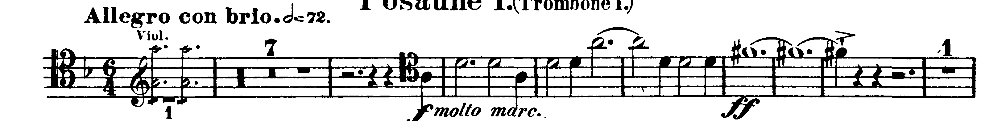

**TCHAIKOVSKY—**Mvt I: D – F

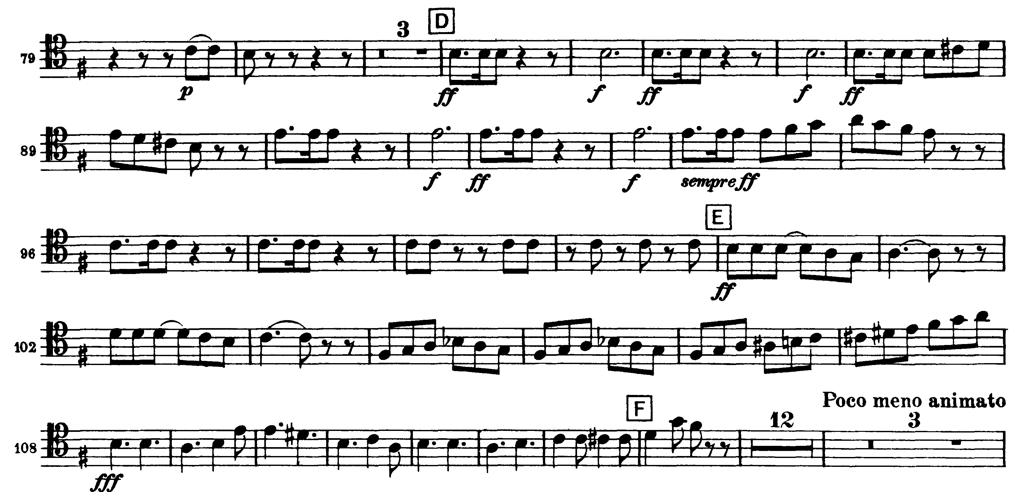

Mvt IV: Aa – Dd

